RESEARCH ASSIGNMENT November 2025

Research title
Characterisation test of biobased sandwich panels and three types of bio-based glues (fish, bone & potato starch based)

Brief description of the research question
Biobased materials are becoming increasingly important as a response to climate change and the need to reduce global carbon emissions. Traditional construction materials such as concrete and steel account for nearly one quarter of the total carbon footprint of the construction sector, and continuing to rely on them without alternatives will further worsen environmental effects.

However, the implementation of biobased materials in construction is not straightforward. Their natural variability, limited engineering knowledge, and uncertainties in long-term performance pose significant challenges for designers and practitioners. Therefore, a deeper understanding of the mechanical behaviour and reliability of biobased materials is essential.

Biobased resources such as bamboo, timber, and naturally derived adhesives offer promising alternatives, but they require comprehensive characterisation before they can be confidently used in structural applications. This project focuses on designing an innovative composite panel made from bamboo, timber, and biobased glue. The developed panel will be built and subsequently tested at BuildinG (www.building.nl) to evaluate its structural behaviour. A sketch of the planned bio-based panels can be seen below.

This research is about testing small components of bamboo-timber-biobased glue compositions for better understanding the full panel behaviour, and especially the behaviour of the bio-based glues.

Actions in this research
- Cut and prepare small bamboo-timber-glue specimens
- Make the glue tests
- Make the timber tests at BuildinG
- Prepare a report for the results, observations, lessons learnt
- Present results at NoorderRuimte Symposium

Connection to NoorderRuimte themes
(Multiple themes possible)
(X) Structural Safety and Earthquakes
(X) Sustainability
Health & Well-being
Liveability

Background of the research assignment and the current situation
Biobased materials are becoming increasingly important within the construction sector, yet their adoption requires thorough testing to ensure they are suitable for practical use. Previous research efforts at BuildinG have included testing timber floor systems and a half-scale building constructed from timber panels. These studies have highlighted the need to better understand the behaviour of the components connecting timber elements, particularly the adhesives. However, suitable biobased adhesives are difficult to find on the market, and the ones that do exist require rigorous evaluation.

In this project, three types of biobased adhesives, derived from animal bone, fish bone, and potato starch, are proposed for use in timber structures. To assess their performance, we propose a new testing campaign using bamboo and plywood elements bonded with these organic glues. The tests will be conducted at BuildinG to evaluate their mechanical behaviour and suitability for structural applications. The results of this campaign will subsequently inform and support a larger-scale testing programme in which bamboo components and biobased adhesives will be combined and evaluated under more complex structural conditions.

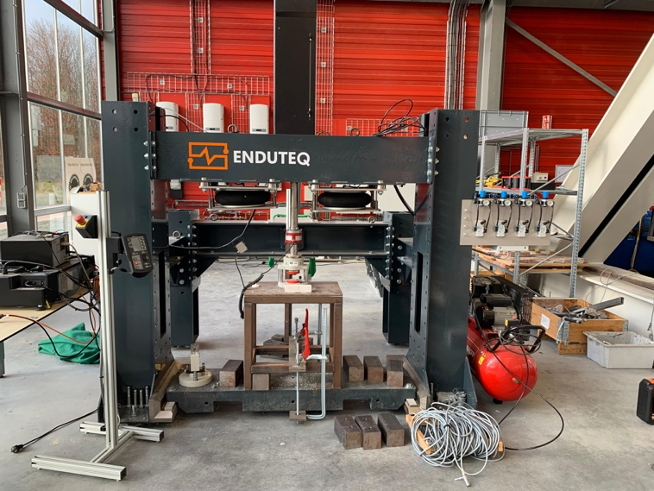
Structural test machine at BuildinG (www.building.nl)

Desired situation regarding the research question
The following activities are required to advance the project:

1)Study the proposed organic glues and bamboo to understand their technical properties and the uncertainties associated with their use in structural applications.

2)Prepare the test samples, consisting of plywood and bamboo elements bonded with the selected organic adhesives, following the configuration shown below.

3)Conduct laboratory tests at BuildinG, using the testing machine to measure key parameters such as ultimate force capacity, shear strength, failure modes, and other mechanical characteristics.

4)Analyse and report the results in the style of an engineering consultancy, providing clear guidance on how these biobased adhesives might perform in real structures and how they should be considered in design.

To successfully complete these steps, the student will need to:

-Review relevant European Norms (EN standards) related to adhesives, timber, and bamboo.

-Study scientific literature and journal papers on similar adhesive–timber or adhesive–bamboo configurations.

-Process and interpret the collected experimental data to generate meaningful insights that can inform the next phase of research.

- The student will receive supervision in the laboratory during all stages of the work to ensure proper execution of the experimental programme and safe handling of materials and equipment.

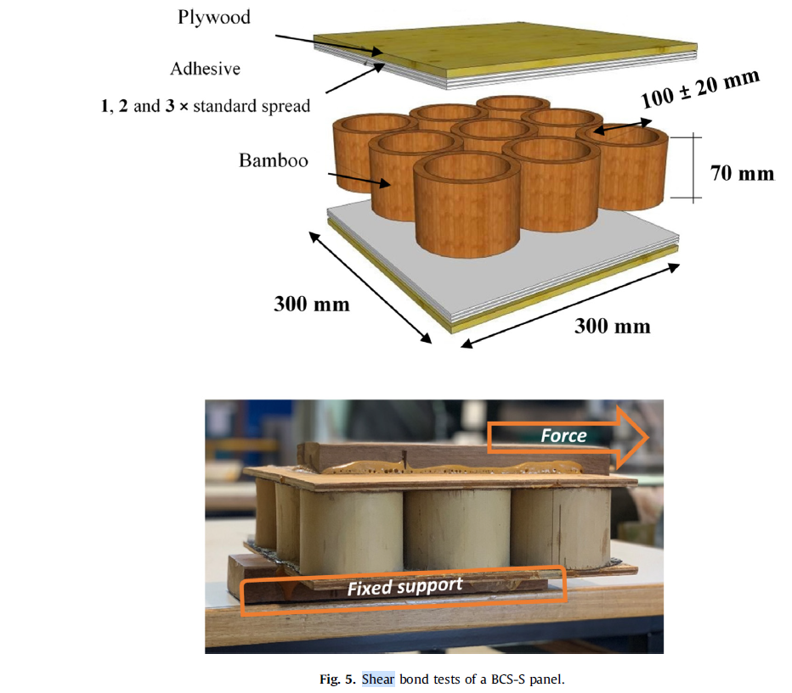
Bamboo-timber specimens for testing

Graduation project, internship assignment …
(You may tick multiple boxes) The assignment is suitable as:

Graduation project as part of bureau NoorderRuimte: one semester in year 4
Internship (possibilities/requirements to be discussed)
Research assignment as part of the curriculum in other year
Honours research assignment
Keuzemodule Profilering (2nd & 3rd year Built Environment SOFE)
Vastgoedlab (3rd year Real Estate Management - one semester)

Vacancies for students of the following studies
Given the nature of this research assignment, the following Bachelor's and Master's level study programs align particularly well with its content and objectives:

- Built Environment, Building Technology , CT, Architecture

The following knowledge/skills are necessary and/or desired
• Basic knowledge of structural materials
• Ability to interpret standards and scientific literature
• Hands-on skills for sample preparation
• Data analysis and engineering reporting
• Critical thinking and problem-solving

Project owner/ manager
Contact: Dr. Onur Arslan
Contact details: (o.arslan@pl.hanze.nl)
Professorship: Structural Safety & Earthquakes
Research program: Bio-based construction materials

